Title: Showdown At Lakeview High
Genre: Action role-playing turn based game with rhythm game aspects

Concept: It is a comical RPG style game, with rhythm game aspects in its combat, set in a highschool with a distinct, colourful art style. The story at first follows the protagonist, Ryo, but soon more characters are introduced and an unlikely bond is formed between four students that become a band. The story follows this group of students as they try and defeat their music teacher.

Setting: Set in a fictional highschool “Lakeview High”, based on typical American highschools that are often seen in Western media. Game environments will feature school classrooms, cafeteria, gym, corridors, and a football pitch.

Characters: Because the game follows classic American highschool student tropes for comical reasons, the main playable characters that join your party are based on the jock, goth nerd, and prep TV tropes. Each is also assigned an instrument as their weapon.
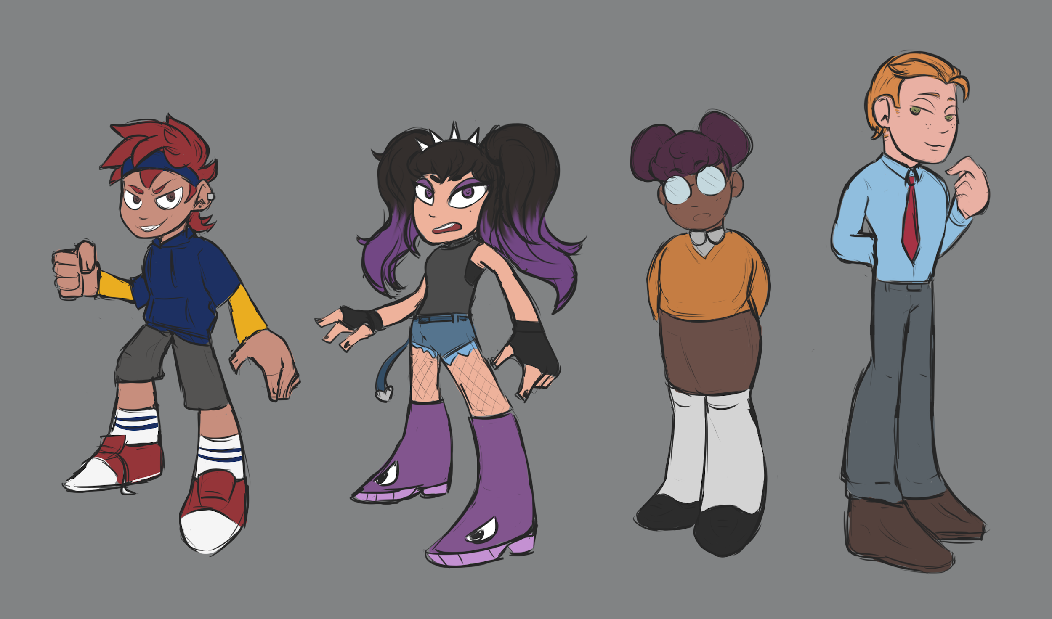
1 - Ryo - The main protagonist and the character the player assumes the role of. His general look and feel as well as attitude is based on classic JRPG protagonists such as Chrono from Chrono Trigger, the Hero from Dragon Quest, as well as Pokemon Trainers from the Pokemon series, modernized. He is an extroverted, highly energetic character who stands up for what he believes in.
Weapon: Guitar

2 - Nikita (Niki) - Overall quite a disinterested girl but becomes friendlier towards the protagonist and the others as the story goes on. Second character that is introduced and joins your party.
Weapon: Bass guitar

3 - Maddie - A shy, closed off but friendly girl. The third character to get introduced and joins your party.
Weapon: Drums

4 - Sean - Last to be introduced; he’s two-faced and manipulative and joins your party for his own gain.
Weapon: Keyboard/Synth

Gameplay:

Inspired by classic RPG games, the general world view will be top down perspective 2D background sprites and small character sprites for the protagonist and NPCs and enemies.
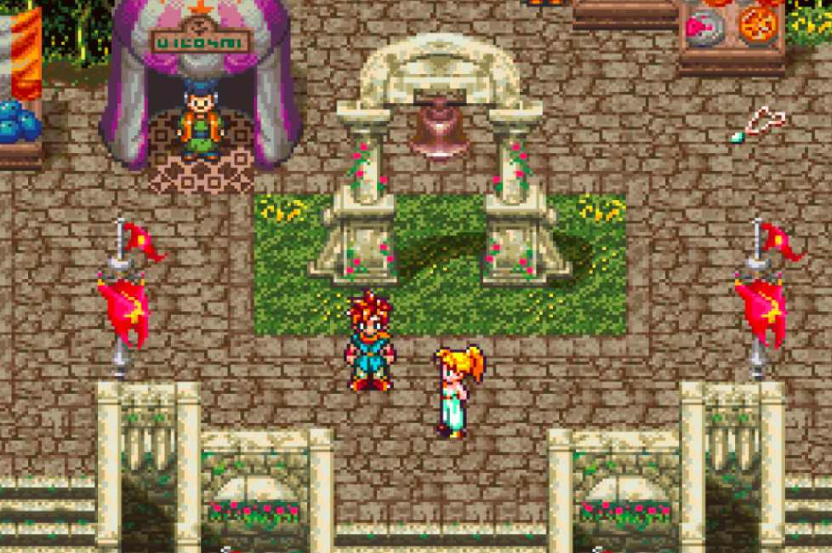
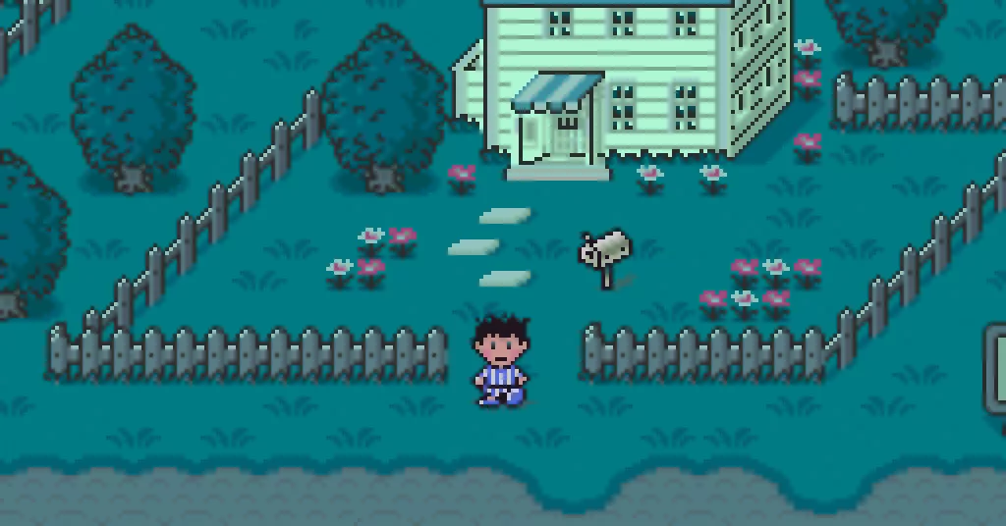
[Earthbound/Mother 2] [Chrono Trigger]

The player will move across the screen and traverse through the school through the different environments such as classrooms and corridors. As you progress, more sections will be unlocked and the difficulty will rise.

Dialogue:

The dialogue will be stylized in boxes at the bottom of the screen with character names and portraits. The art that will be featured in the portraits will be detailed and stylized art of the characters with a variety of expressions that will change depending on the mood of what is being said.

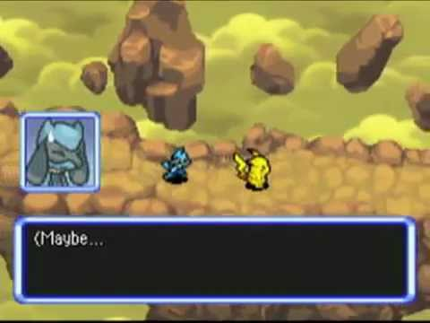
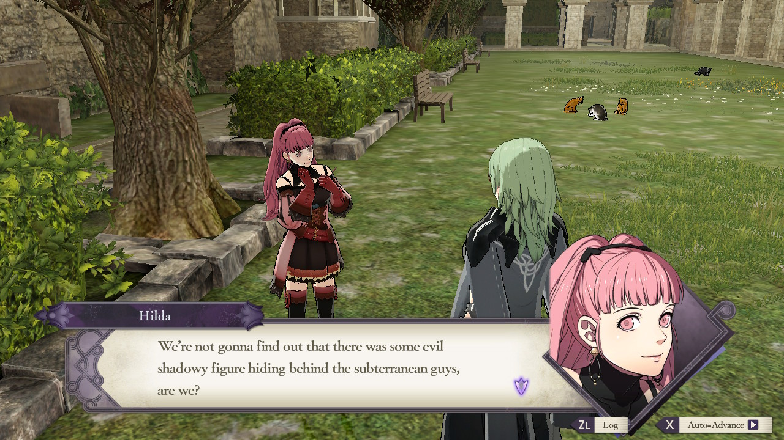
[Pokemon Mystery Dungeon: [Fire Emblem: Three Houses]
Explorers of Sky/Darkness]

Combat:

As the player progresses they will encounter a variety of enemies (other students and teachers), the fights are triggered when the player gets into the enemy’s line of sight. All characters play instruments that are used in battle - essentially they attack using music.

The combat will also be set out like a classic RPG, with sprites of the characters in party on one side and enemies on the other, portraits of the party members will be displayed on one side also showing their HP and MP and Special gauge.

There will be three varieties of damage dealing attacks; basic attack, magic attacks that use MP, as well as special attacks. The special attacks require a gauge to fill up during the combat, once it is full, the special can be used. Each character will have different specials that are unique to them and the special will require the player to perform certain actions in real time such as pressing buttons in time to the music. The better the player does, the stronger the attack will be. This adds another layer to the strategy in the combat and will be a unique key feature in the game.

Additionally, there will be elemental advantages and disadvantages with magic attacks, healing magic and buff/debuff magic.

There will be an EXP and Level system, characters will level up after defeating enemies. As the player progresses through the game, the enemies will be higher levels and will slowly introduce more element types for a bigger variety in combat strategy and difficulty.

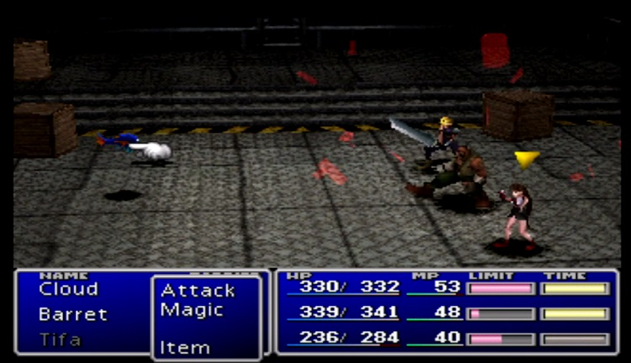
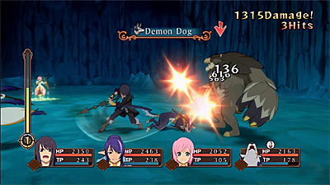

[Tales of Vesperia] [Final Fantasy VII]

Story Outline:

The new music teacher at Lakeview High is giving most of the students low grades for their work as he is very biased and dislikes any music that is vaguely aggressive and loud. Ryo decides this is unfair on everyone and wants to change that (by getting rid of him). Niki overhears and joins him on his plans since that means she gets to play what she likes. Later on, Maddie joins them as she believes her grades are unacceptable and wants to change that. After this information spreads around the school, Sean uses it to his advantage and also joins them in hopes of being able to overthrow the music department and then the whole school.

The story progresses with the game, as information spread, more teachers and other students try to stop your team from reaching your goal - to reach the music teacher and defeat him, who acts as the final boss in the game.

